**Microprocessor Lab**

Laboratory Activity No. 1

**Familiarization with TinkerCAD**

|  |
| --- |
|  |

Score

*Submitted by:*

**Tiu, Joshua Miguel Yaj A.**

**<Saturday 10:00-11:00> / <CPE 0412.1-1>**

*Date Submitted*

**16-09-2023**

*Submitted to:*

**Engr. Maria Rizette H. Sayo**

1. Exercise

a. A process in Tinkercad where we can develop electronic circuits that can be quickly updated, modified, and tested is called Prototyping Process.

b. In Tinkercad, Start/Stop Simulation tests the working of the circuits and the components.

c. The device used to assemble and connect the various components is known as Breadboard.

d. In an electronic circuit with LED, the positive end of the circuit should be connected to

anode and negative end should be connected to cathode of the LED.

e. A resistor is used to restrict the flow of current to electrical components.

2. Label the following:

1. Anode and Cathode in a LED

* The anode which is the Positive pin or leg of the LED is the long leg or the one with a bent part. While the cathode is the negative pin or leg of the LED which is the short leg or the straight-out part.

1. Different parts of breadboard

-Consist of two Terminal Strips with 5 hole rows, 2 power rails that consists of positive and negative ground. The black row or the negative of the power rails is the for the ground and the red row of the power rails is for the 3.3v power. Last is the center divider or the DIP support.

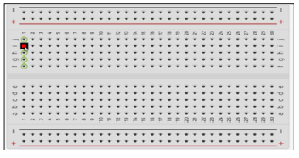

Center Divider/DIP Support

Terminal Strips

Power Rails

1. List the electronic components used in a circuit assembly

* Resistor
* LED
* Pushbutton
* Potentiometer
* Capacitor
* Slideswitch
* 9V Battery
* Coin Cell 3V Battery
* 1.5 Battery
* Breadboard
* Micro:bit
* Arduino Uno R3
* Vibration Motor
* DC Motor
* Micro Servo
* Hobby Gearmotor
* NPN Transistor (BJT)
* LED RGB
* Diode
* Photoresistor
* Soil Moisture Sensor
* Ultrasonic Distance Sensor
* PIR Sensor
* Piezo Sensor
* Temperature Sensor (TMP36)
* Multimeter